Jmeter Performance Testing Course Works

Author: Thao Le

Contents

1. Week 7 Course Works: Remote Jmeter, Plugins Manager, Variables 3

# Week 7 Course Works: Remote Jmeter, Plugins Manager, Variables

* + **Set up Remote to run KIJIJI Login Test Plan in 2 remotes and 1 client:**
    - Step 1: Start the servers
    - To run JMeter in remote node, start the JMeter server component on all machines you wish to run on by running the JMETER_HOME/bin/jmeter-server
    - Step 2: Add the server IP to your client's Properties File
* Edit the properties file on the JMeter Client machine. In JMETER_HOME/bin/jmeter.properties, find the property named, "remote_hosts", and add the value of your running JMeter server's IP address. Multiple such servers can be added, comma-delimited.
  + - Step 3a: Start the JMeter Client from a GUI client to check configuration
    - Start the client with the script "bin/jmeter.bat". For UNIX, use the script "bin/jmeter". You will notice that the Run menu contains two new sub-menus: "Remote Start" and "Remote Stop" (see figure 1). These menus contain the client that you set in the properties file. Use the remote start and stop instead of the normal JMeter start and stop menu items.

[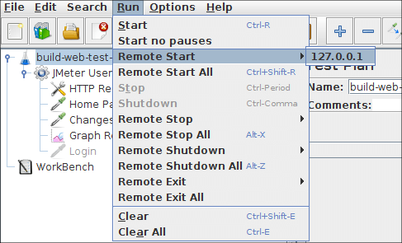](https://jmeter.apache.org/images/screenshots/remote/run-menu00.png)

* + - Step 3b: Start the JMeter from a non-GUI Client
    - GUI mode should only be used for debugging, as a better alternative, you should start the test on remote server(s) from a non-GUI (command-line) client. The command to do this is:
      * jmeter -n -t Kijiji_Website_Remote.jmx -r -l testresult.jtl
    - or
      * jmeter -n -t Kijiji_Website_Remote.jmx -R server1, server2, …-l testresult.jtl
    - Other flags that may be useful: -X to Exit remote servers at the end of the test.
    - Step 4: Stop the remote server: use Ctr+C
* **Install Plugin Manager**
* **Using User Define Variables for KIJIJI Login Test Plan:**
  + Open KIJIJI Login test plan, under Thread Group, add User Define Variables
  + Add Email and Password variables
  + Run Test Plan

